Exp No: 5  Date: 5.4.25 | HTTP PST AND GET

AIM:

To write a servlet to demonstrate the difference between HTTP GET and POST methods by creating a form and hadling requests accordingly

PROGRAM:

Login.java :
package siva.servlet;
import java.io.IOException;
import java.io.PrintWriter;
import javax.servlet.ServletException;
import javax.servlet.annotation.WebServlet;
import javax.servlet.http.HttpServlet;
import javax.servlet.http.HttpServletRequest;
import javax.servlet.http.HttpServletResponse;
/**
* Servlet implementation class SignupDetails
*/
@WebServlet("/signup")
public class signup extends HttpServlet {
private static final long serialVersionUID = 1L;
/**
* @see HttpServlet#HttpServlet()
*/
public signup() {
super();
// TODO Auto-generated constructor stub
}
/**
* @see HttpServlet#doGet(HttpServletRequest request, HttpServletResponse response)
*/
protected void doGet(HttpServletRequest request, HttpServletResponse response) throws ServletException, IOException {
// TODO Auto-generated method stub
response.getWriter().append("Served at: ").append(request.getContextPath());
}
/**
* @see HttpServlet#doPost(HttpServletRequest request, HttpServletResponse response)
*/
protected void doPost(HttpServletRequest request, HttpServletResponse response) throws ServletException, IOException {
String f_name=request.getParameter("fname");
String l_name=request.getParameter("lname");
String DOB=request.getParameter("dob");
String gen=request.getParameter("gender");
String add=request.getParameter("address");
PrintWriter p = response.getWriter();
p.println("First Name: "+f_name+"<br>");
p.println("Last Name: "+l_name+"<br>");
p.print("Age: "+DOB+"<br>");
p.print("Gender: "+gen+"<br>");
p.print("Address: "+add+"<br>");
}
}

SignupDetails.jsp :

<!DOCTYPE html>
<html>
<head>
<meta charset="ISO-8859-1">
<title>Insert title here</title>
</head>
<body>
<h1 style="color:blue">SIGNUP FORM</h1>
<form method="post" action="/signup">
<label for="fname">First Name:</label>
<input type="text" id="fname" name="fname" placeholder="Enter your first name" required><br><br>
<label for="lname">Last Name:</label>
<input type="text" id="lname" name="lname" placeholder="Enter your last name" required><br><br>
<label for="dob">Date of Birth:</label>
<input type="date" id="dob" name="dob" required><br><br>
<p>
<label for="gender">Gender: </label>
<label for="male">Male </label>
<input type="radio" id="male" name="gender" value="Male">
<label for="female">Female </label>
<input type="radio" id="male" name="gender" value="Female"><br><br>
</p>
<label for="address">Address</label>
<textarea type="text" name="address"></textarea><br><br>
<input type="submit" value="SignUp">
</form>
</body>
</html>

OUTPUT:

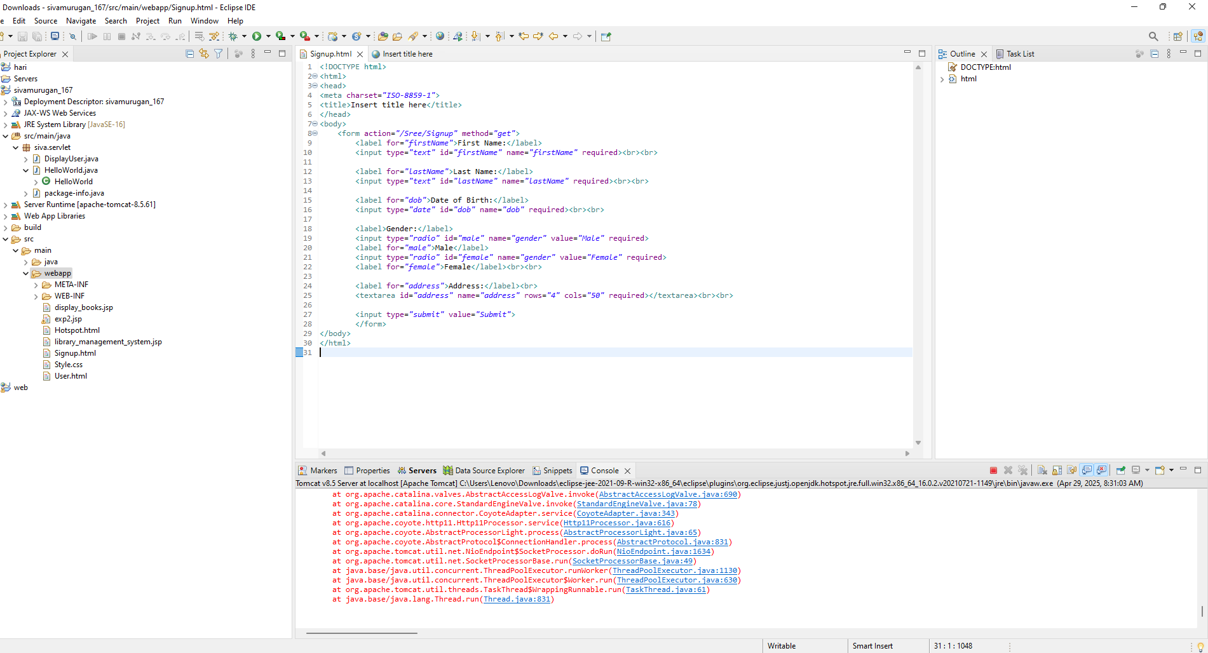

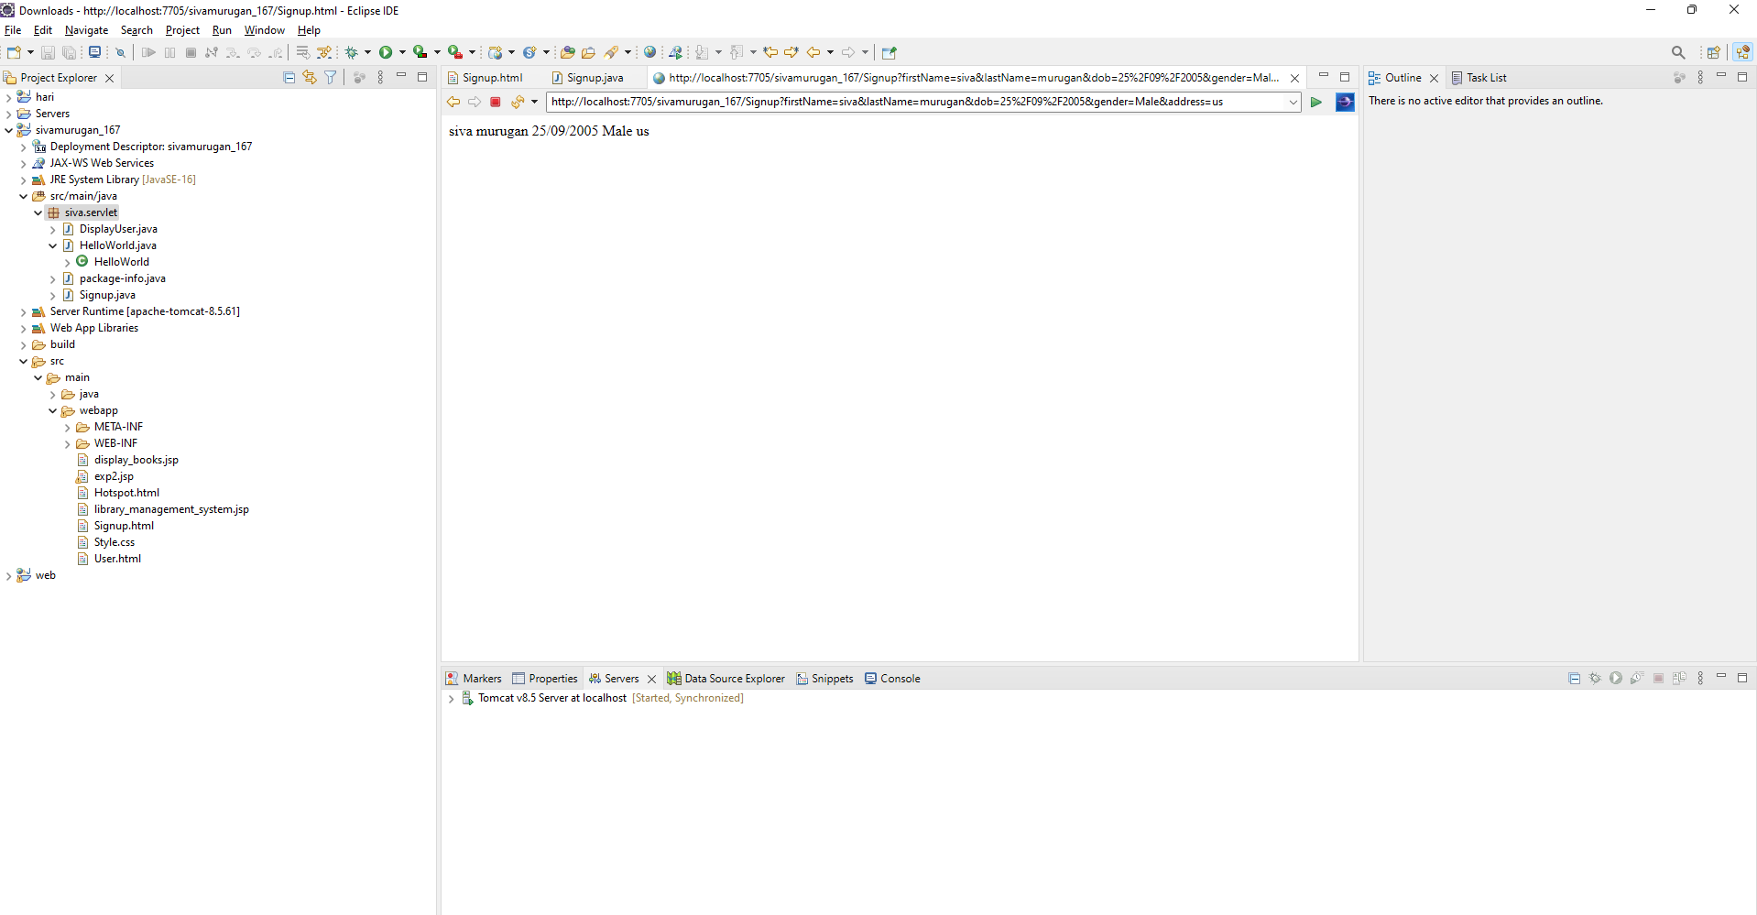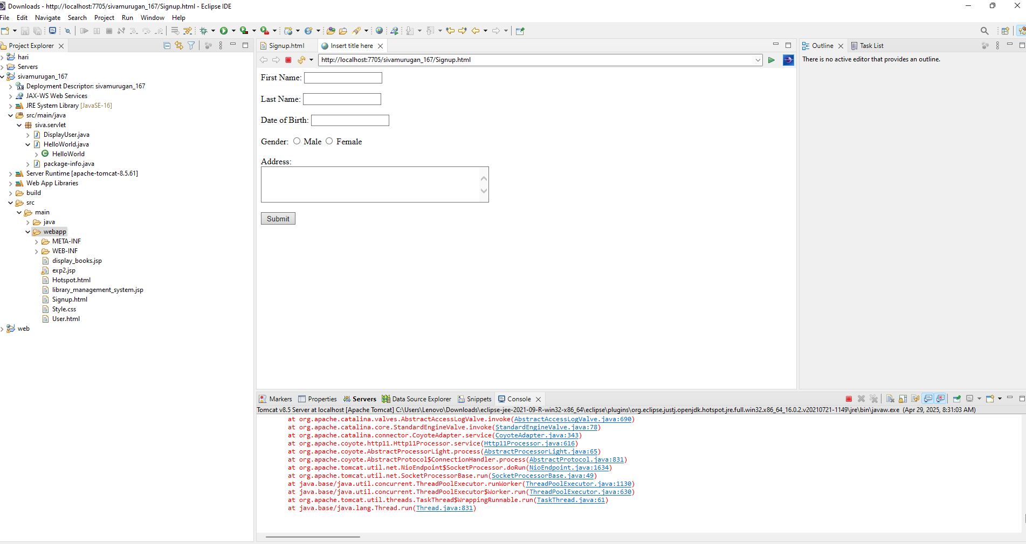

RESULT :
Thus the experiment to write a servlet to demonstrate the difference between HTTP GET and POST methods by creating a form and hadling requests accordingly has been implemented and verified successfully

